Create Analysis Sequence Diagrams based on non-trivial tasks. For some of these ASDs, develop them further into a Design Sequence Diagram. Add descriptions for the list of steps in each diagram

**Reference** [**Lecture 15**](https://courses.maine.edu/d2l/le/content/332616/viewContent/8971972/View) **for guidelines to develop the diagrams for this document**

Ideas: Starting a game, Exploring a room, Drawing a card, Making a roll, Changing character stats, Picking up an Item, Using an item, Attacking a target, Triggering the haunt, Character death

**1: Logging In (Ryan)**

Analysis Sequence Diagram:

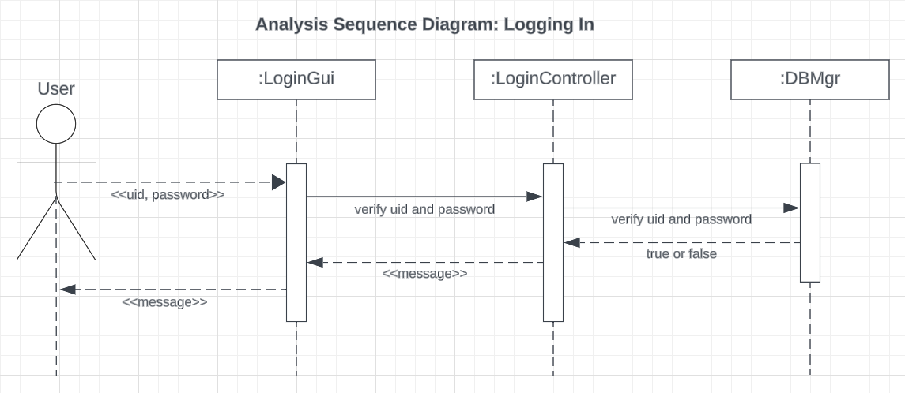

Design Sequence Diagram:

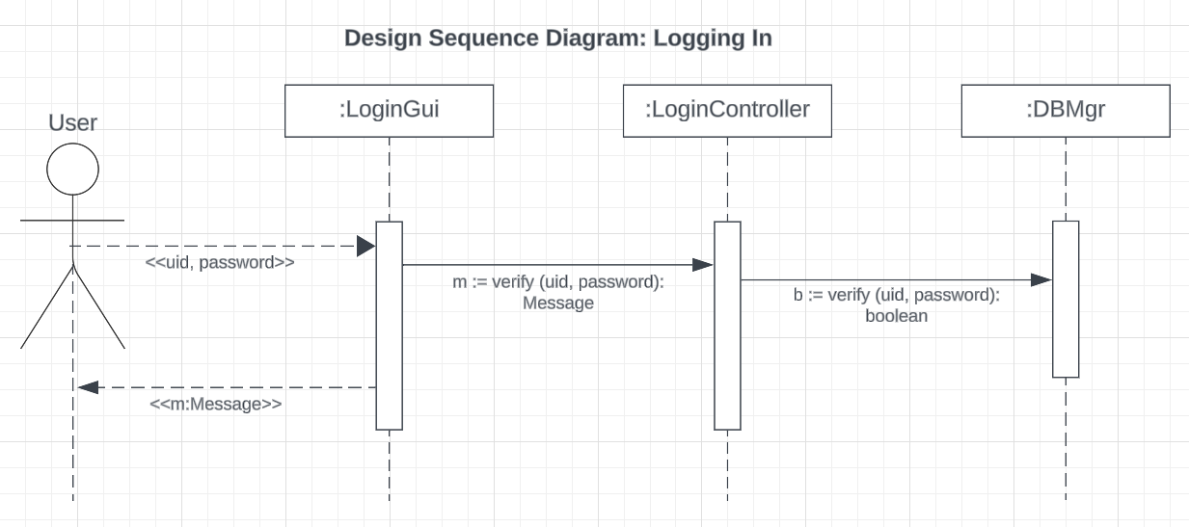

Description:

| **#** | **Subject** | **Subject Action** | **Parameters** | **Object Acted On** |
| --- | --- | --- | --- | --- |
| 1 | User | enters | *uid, password* | Login GUI |
| 1.1 | Login GUI | verifies | *uid, password* | Login Controller |
| 1.2 | Login Controller | verifies | *uid, password* | Database manager |
| 1.3 | Database manager | returns | true or false to | Login controller |
| 1.4 | Login Controller | returns | *message* | Login GUI |
| 1.5 | Login GUI | displays | *message* | User |

**2: Changing Settings (Ryan)**

Analysis Sequence Diagram:

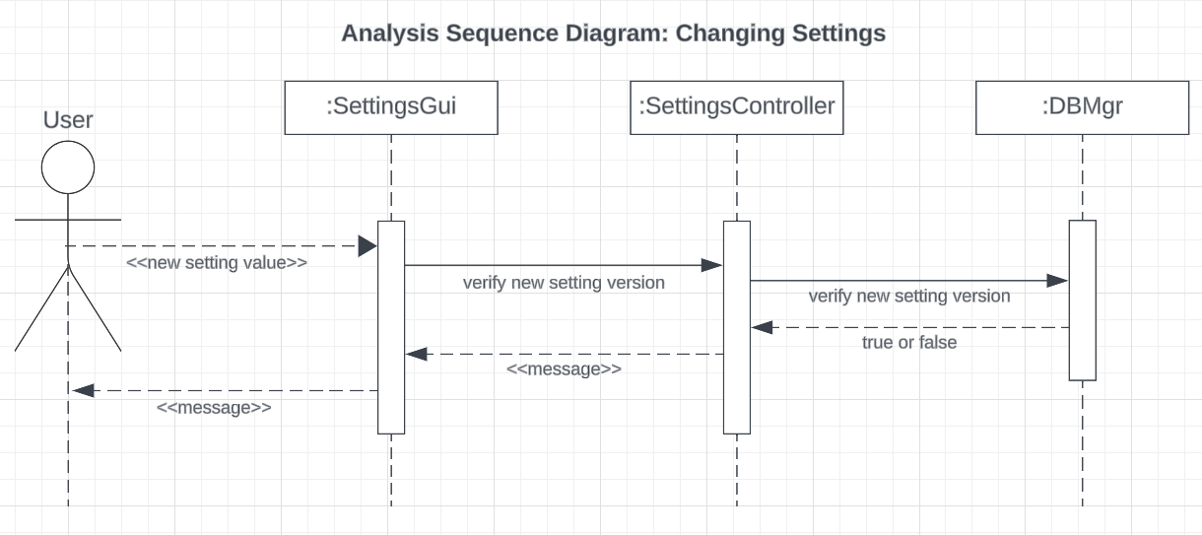

Description:

| **#** | **Subject** | **Subject Action** | **Parameters** | **Object Acted On** |
| --- | --- | --- | --- | --- |
| 2 | User | enters | *Setting changes* | Settings GUI |
| 2.1 | Settings GUI | verifies | *Setting changes* | Settings Controller |
| 2.2 | Settings Controller | verifies | *Setting changes* | Database manager |
| 2.3 | Database manager | returns | true or false to | Settings controller |
| 2.4 | Settings Controller | returns | *message* | Settings GUI |
| 2.5 | Settings GUI | displays | *message* | User |

**3: Viewing Player Stats (Ryan)**

Analysis Sequence Diagram:

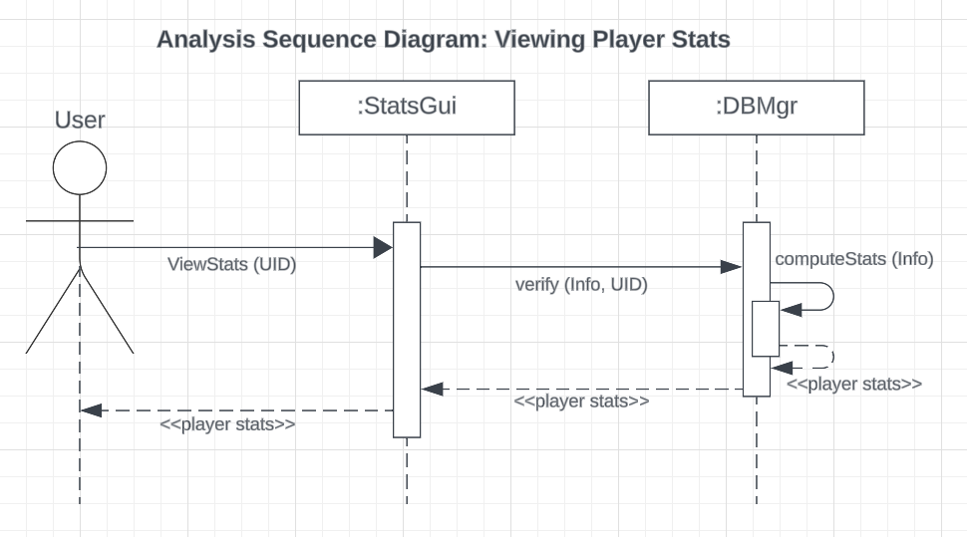

Description:

| **#** | **Subject** | **Subject Action** | **Parameters** | **Object Acted On** |
| --- | --- | --- | --- | --- |
| 3 | User | views | *uid* | Stats GUI |
| 3.1 | Stats GUI | verifies | *Player info, uid* | Database manager |
| 3.1.1 | Database manager | compute | *info* | Database manager |
| 3.1.2 | Database manager | returns | *Player stats* | Database manager |
| 3.2 | Database manager | returns | *Player stats* | Stats GUI |
| 3.3 | Stats GUI | displays | *Player stats* | User |

**4: Attacking a Target (Ethan)**

Analysis Sequence Diagram:

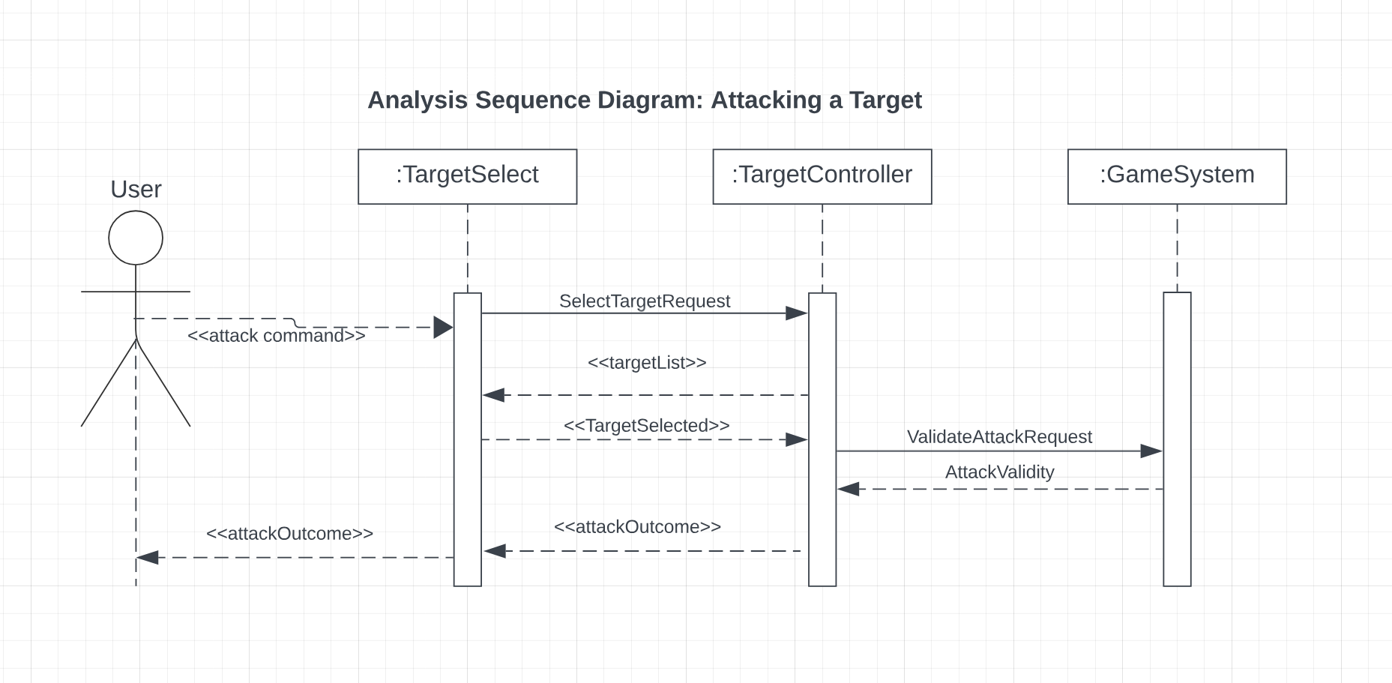

Design Sequence Diagram:

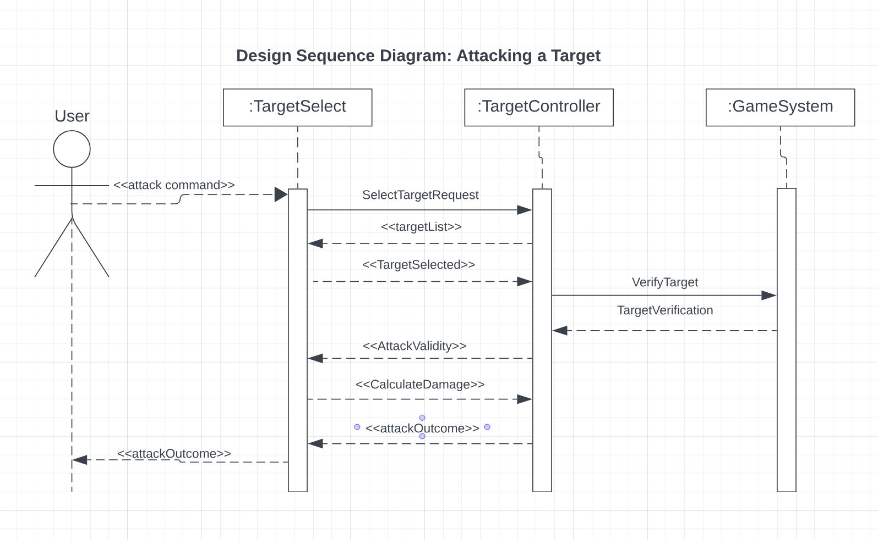

Description:

|  | Subject | Subjects Action | Other Data | Object Acted On |
| --- | --- | --- | --- | --- |
| 4 | User | Initiates | Attack Command | Target Select |
| 4.1 | Target Select | Sends | Target Select | Target Controller |
| 4.2 | Target Controller | Returns | List of targets | Target Select |
| 4.3 | Target Select | Selects | Target | Target Controller |
| 4.4 | Target Controller | Validates | Attack request | Game System |
| 4.5 | Game System | Validates | Attack request | Target Controller |
| 4.6 | Target Controller | Provides | Attack outcome | Target Select |
| 4.7 | Target Select | Displays | Attack outcome | User |

**5: Using an Item (Ethan)**

Analysis Sequence Diagram:

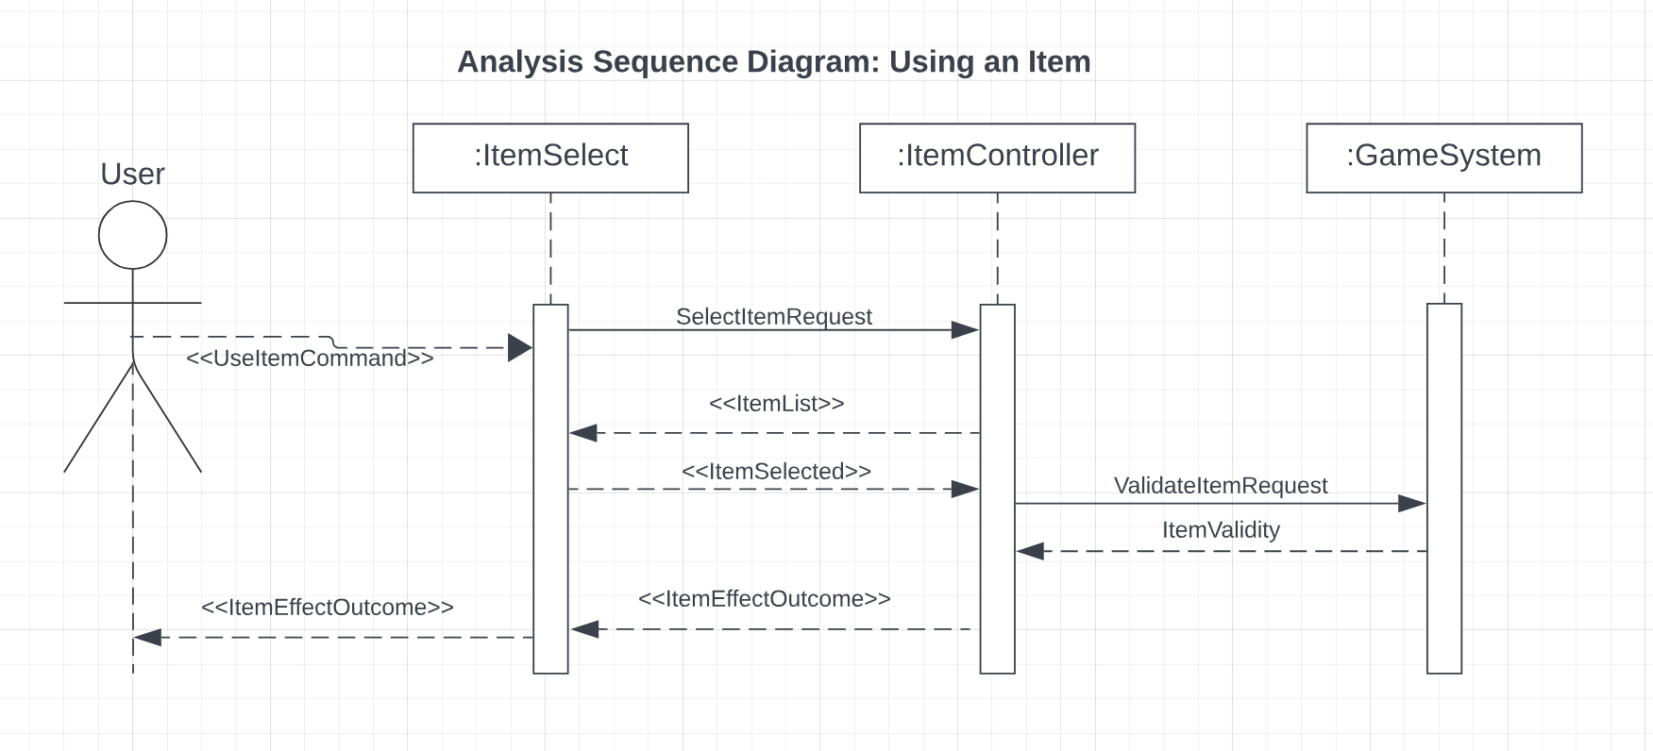

Description:

|  | Subject | Subjects Action | Other Data | Object Acted On |
| --- | --- | --- | --- | --- |
| 5 | User | Initiates Item Use Command | Item Use | Item Select |
| 5.1 | Item Select | Sends Select Item Request | - | Item Controller |
| 5.2 | Item Controller | Provides List of Items owned by Player | Item List | Item Select |
| 5.3 | Item Select | Selected Item is chosen | Selected Item | Item Controller |
| 5.4 | Item Controller | Validates the Item use request | Item Use request | Game System |
| 5.5 | Game System | Validates the Item Use | - | Item Controller |
| 5.6 | Item Controller | Item and its effect outcome | Item Effect | Target Select |
| 5.7 | Target Select | Item and its effect outcome | Item Effect | User |

**6: Starting a Game (Patrick)**

Analysis Sequence Diagram:

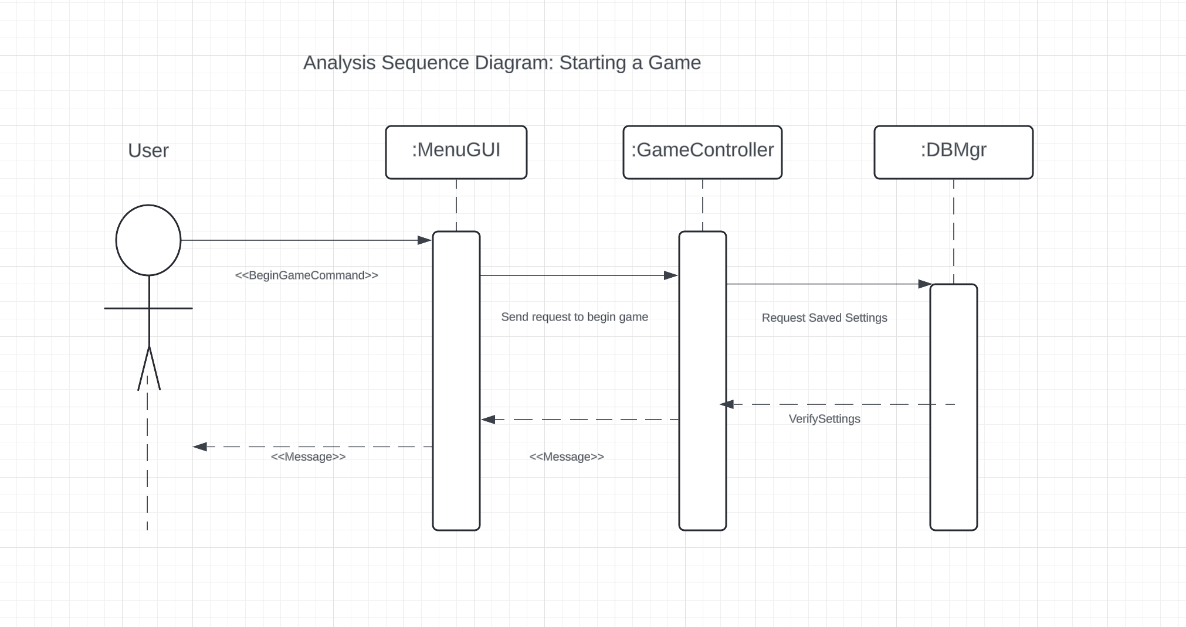

Design Sequence Diagram:

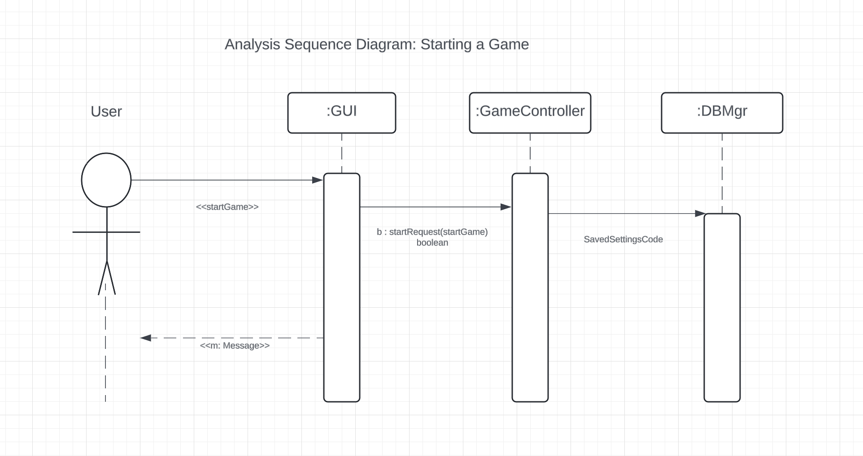

Description TEMPLATE:

| **#** | **Subject** | **Subject Action** | **Parameters** | **Object Acted On** |
| --- | --- | --- | --- | --- |
| 1 | User | Activates | StartGameCommand | Menu GUI |
| 2.1 | Menu GUI | Requests | StartGameCommand | Game Controller |
| 2.2 | Game Controller | Requests | SavedSettingsCode | Database manager |
| 2.3 | Database manager | Verifies | ValidityCode | Game Controller |
| 2.4 | Game Controller | returns | *message* | Menu GUI |
| 2.5 | Menu GUI | returns | *message* | User |

**7: Character Death (Patrick)**

Analysis Sequence Diagram:

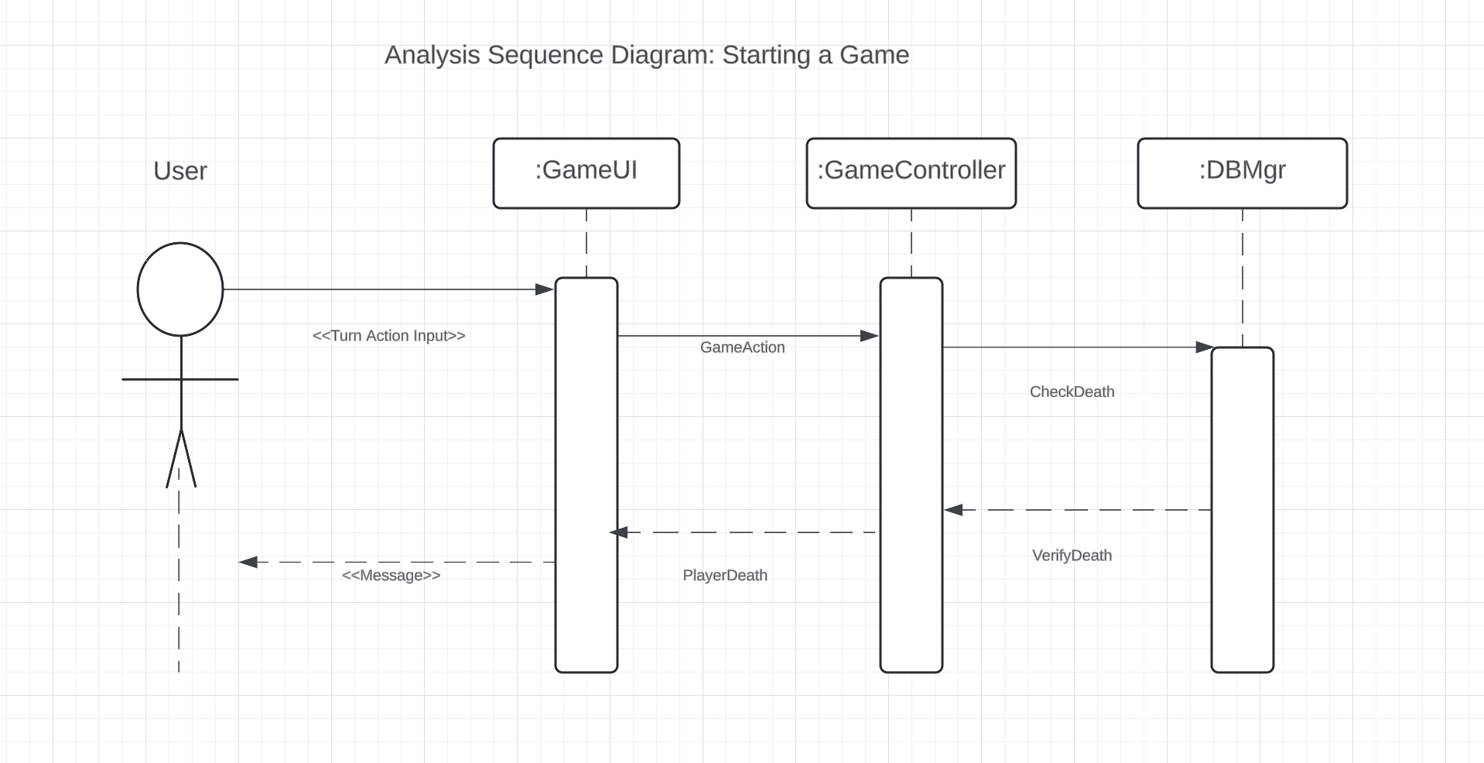

| **#** | **Subject** | **Subject Action** | **Parameters** | **Object Acted On** |
| --- | --- | --- | --- | --- |
| 1 | User | Inputs | Input | Game UI |
| 2.1 | Game UI | Executes | GameAction | Game Controller |
| 2.2 | Game Controller | Check | DeathCondition | Database manager |
| 2.3 | Database manager | Returns | VerificationCode | Game Controller |
| 2.4 | Game Controller | Executes | PlayerDeathStatus | Game UI |
| 2.5 | Game UI | Displays | *message* | User |